**Write a blog about objects and its internal representation in Javascript**

**What is object in javascript**

Objects, in javascript is not like primitive data type means primitive data types are store only one value like some string or numbers or Boolean value like true or false or undefined or null. Instead of that object store collection of data in a form of key-value pair.

**Ex**

const person={

name:”siddiq”,

age:26,

married:false,

}

This is an example of an object as you can see it has collection data and the data type also different from one and another **name** as a **String, age** as a **Number** and **married** as a **Boolean** data type.

Keyes are left side of the colon **name, age, married** and other side means right side of the colon are called values **“siddiq”, 26, false.**In javascript almost everything is an object.

**Internal representation of objects in javascript**

JavaScript objects are not stored in memory as a continuous block of data. Instead, each object is represented internally as a collection of key-value pairs. When you create an object in JavaScript, the JavaScript engine allocates memory for the object and initializes its internal representation.

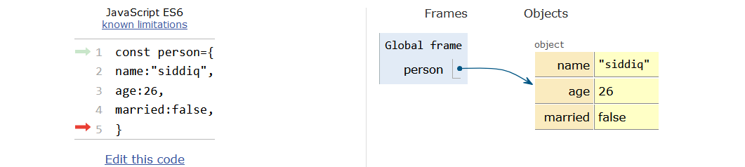

**In simple language**

Internal representation is nothing , a value is represent by a key and the key value pair represent by an object name.

**Conclusion**

JavaScript objects are a powerful feature of the language that allow you to represent complex data structures. In javascript almost everything is object so that is very important to know how object works.